**Objective of the Lab/Program**

The objective of this program is to find the prime numbers between a range of number inclusive of the input.

**Assembly Source Codes**

#program to calculate sum of numbers

.data

A : .asciiz "\nPlease enter A(Lower Bound): "

B : .asciiz "\Please enter B(Upper Bound): "

str1 : .asciiz "\nPlease input: "

str2 : .asciiz "\nBoth A and B are the same value"

str3 : .asciiz "\nError: Number needs to be positive"

str4: .asciiz "\nNo Prime value exists in this range"

.text

#Storing variable A in register $s0

la $a0,A

li $v0, 4

syscall

li $v0,5

syscall

move $s0, $v0

#Storing variable B in register $s1

la $a0,B

li $v0, 4

syscall

li $v0,5

syscall

move $s1, $v0

#Check if negative

bltz $s0, negative

bltz $s1, negative

#Check if same

beq $s0, $s1, same

#variable definition

move $s3, $s0 #outer increment defined as low

li $s4, 2 #increment count

li $s5, 2 #Used to split in half

move $t1, $0

#Loop for primes

loop1:

div $s3, $s5

beq $s3, 1 ,noprime

li $s4, 2

mflo $s6 #Used as half point

loop2:

div $s3, $s4

mfhi $s7

beqz $s7,noprime #if remainder = 0 exit

beq $s4, $s6, prime #prints if prime

addi $s4, $s4 , 1

j loop2

noprime:

beq $s6, 1, prime #specail case where the mid point is 1, only runs for when looking at 2 and 3

beq $s3, $s1 , endnopr

addi $s3, $s3, 1

j loop1

prime:

beq $s3, $s1 , endpr

move $a0, $s3

li $t1, 1

li $v0, 1 #print, including syscall

syscall

addi $s3, $s3, 1

j loop1

endpr:

move $a0, $s3

li $t1, 1 #boolean for if prime exists in range

li $v0, 1

syscall

li $v0, 10 #terminate program

syscall

endnopr:

beqz $t1, nevpr

end:

li $v0, 10 #terminate program

syscall

negative:

la $a0,str3

li $v0, 4

syscall

li $v0, 5

li $v0, 10

syscall

same:

la $a0,str2

li $v0, 4

syscall

li $v0, 10

syscall

nevpr:

la $a0,str4

li $v0, 4

syscall

li $v0, 10

syscall

**Screen shot of the results**

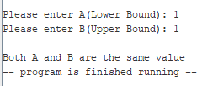

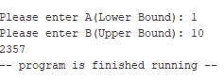

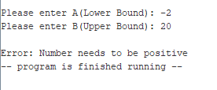

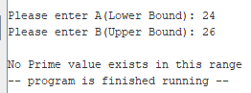

**Conclusion and References**

After nesting two loops the program is able to check all the prime numbers inside a range. It also has escape cases which stop the program if: there are no prime numbers in the range, one input is negative and both inputs are the same.